Quick View User Guide-
To set up the Quick View feature, sign in to your Shopify admin, go to Online Store → Themes, and select Customize.

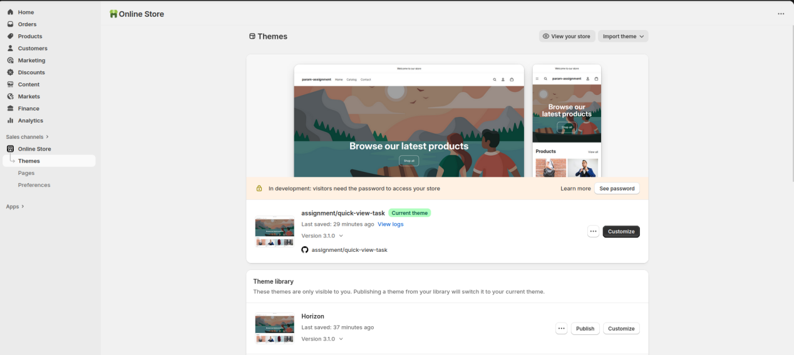

Next, configure the global settings for the Quick View feature, such as font size, line height, and the icon position.

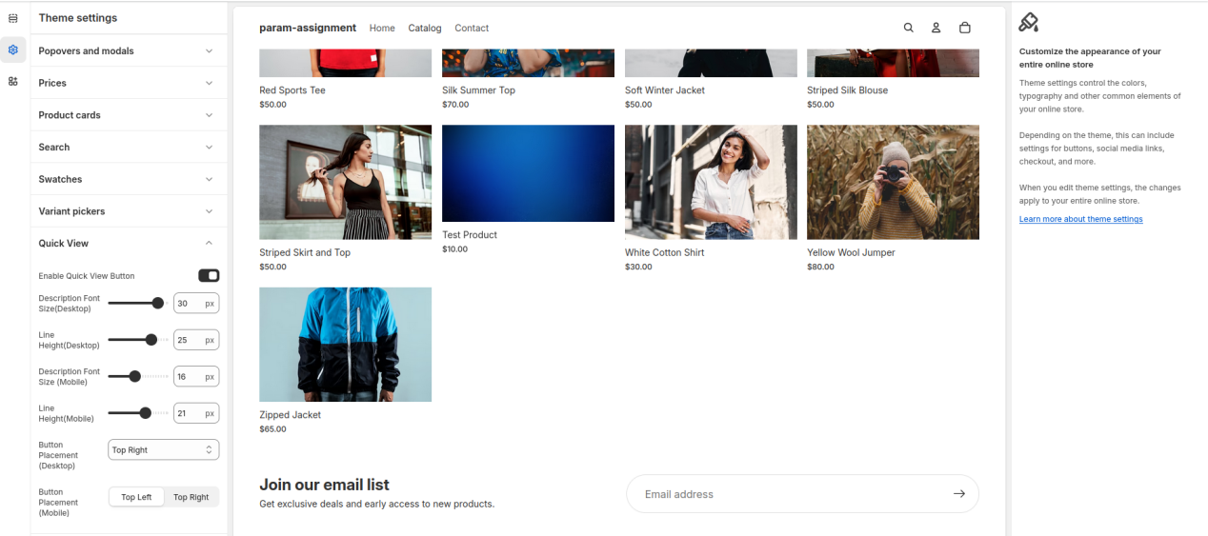
Then, add the “Quick View Configuration” block to the desired section — such as the collection page, home page, or any product card section.
Within this block, you’ll find drag-and-drop options to arrange elements like the title, image, price, description, variant selector, and Add to Cart button.

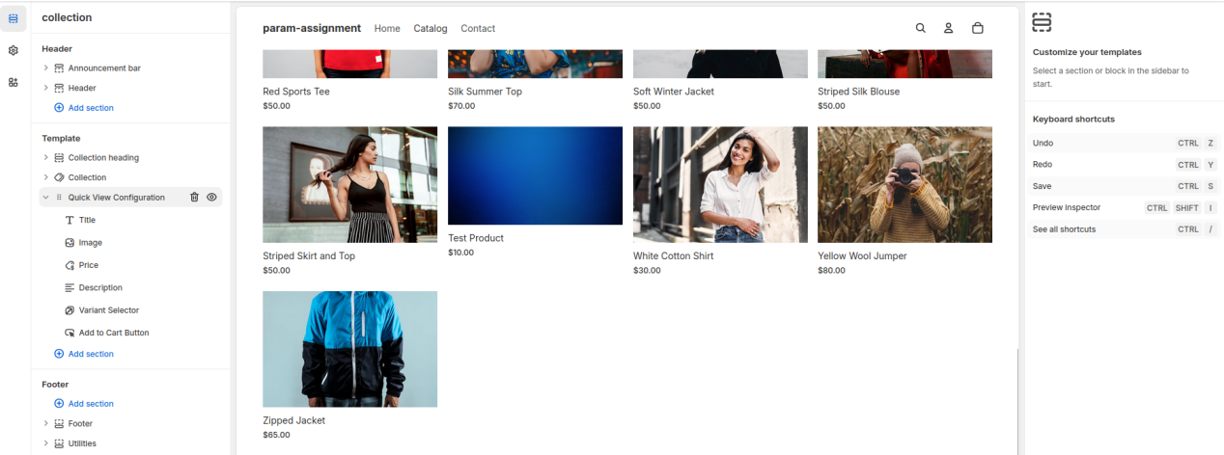

You’ll then see the Quick View icon appear on the product card. You can adjust its position for both mobile and desktop from the Global Quick View Configuration settings.
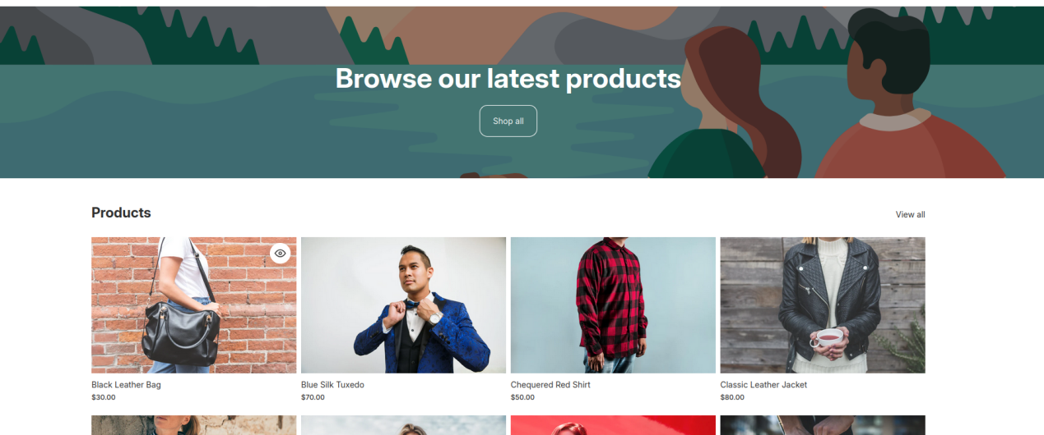

When you click the Quick View icon, a popup will appear displaying the product details. You can reorder the elements within this popup (such as the image, title, price, description, variants, and Add to Cart button) as needed.

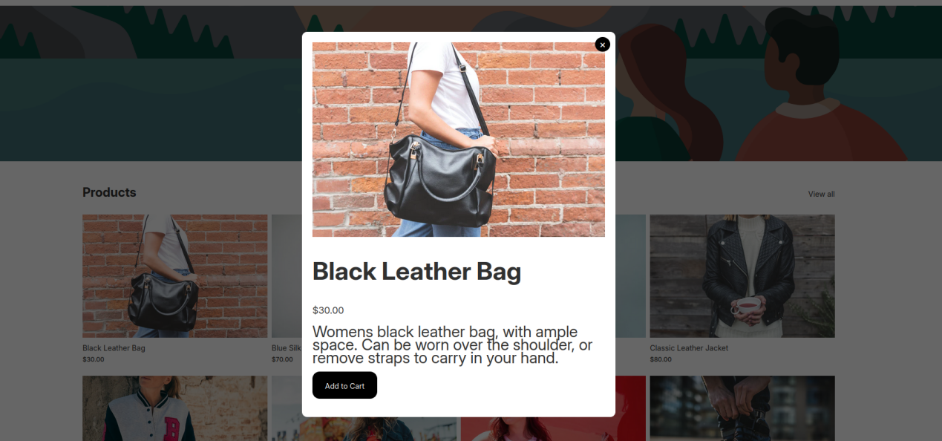
PDP Media Filter by Color Variant - User Guide
We’ll be implementing variant color filtering on the Product Detail Page (PDP). To enable this feature, you’ll need to add alt text values to the product images. These values will allow users to filter the image gallery based on color.
Follow the steps below to add alt text (which should include the color name):
- Log in to your Shopify admin panel at shopify.com/login using your store credentials.
- From the left-hand sidebar, click on Products to open your product list.
- Click on the title of the product you want to edit.
- On the product details page, scroll down to the Media section — you’ll see all the images uploaded for that product.
- Click on the image you want to edit. A pop-up window will appear, allowing you to modify the image details.
- In the Alt text field, enter the color name that matches the product variation (for example: Blue, Black, or Green).
- Click Done or Save to apply the changes.
When creating a variable product and adding media, make sure to add image alt text for each image.
The alt text should exactly match the option name used in the product variations — for example, Blue, Black, or Green.
This ensures that images are correctly filtered and displayed based on the selected variation.

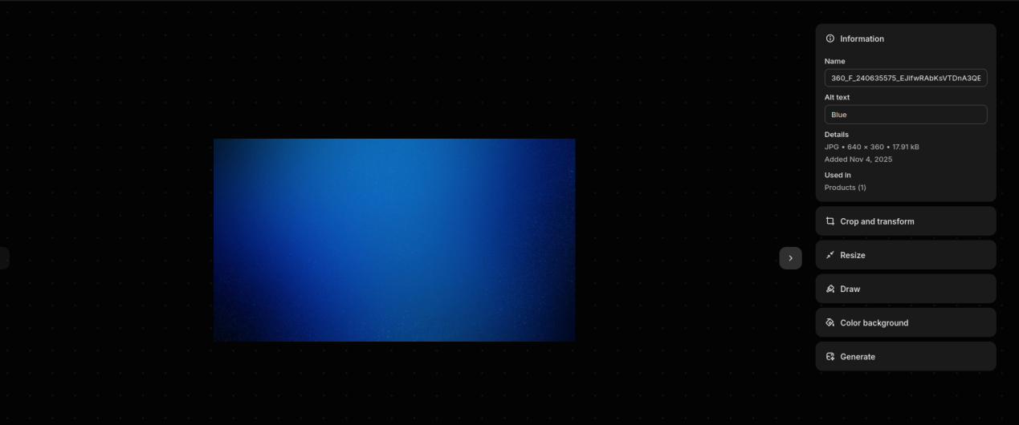

Next, select the theme-media template from the Theme template dropdown menu.

